# 20190828 Tech A11y Roundtable

## Meeting Notes

Date: 08/28/2019

Attendees: Megha, Gopi, Krishna, Gareth, Katie K, Katie R, Mike, Abdul, Sumit

Presenter: Mike Mistak

## Greetings and Share - 18 minutes:

Greetings and share what is going well? What are the opportunities? Gaps?

* Megha – working on new requirements, new skills, seeing a11y issues but not able to fix because of scope, AEM dev
* Gopi – not much a11y, UI dev new feature, save plan visitor
* Krishna – last sprint worked on a11y stories, no uniformity on tooltip so confusion with managing focus, on the same page two different implementations
* Abdul – SAM no challenges on that

## Presentation - 10 minutes: Single page apps (Angular and React)

### Powerpoint: Angular & React Accessibility (A11Y) Basics

#### Vanilla HTML

* Gold Standard of Accessibility Friendly Development
* Least need to make special accommodations specifically for Accessibility

#### Single Page Applications (Using Angular, React, etc.)

* Changes many of the basic tenants of how the web works
* By default often operate in a way contrary to how Assistive Technology works to aid users
* Often override other settings that enable Accessibility
* May have Accessibility Capabilities but often those capabilities are not enabled by default.

#### What do we need to understand about SPA Frameworks like Angular & React?

* **Frameworks Generally Abstract Away the HTML Layer:** Meaningful HTML is Vital to A11Y
* **SPA interactions can alter the ability to Keyboard Navigate:** Keyboard Navigation is Fundamental to Accessibility
* **Frameworks often override Visible Focus:** Visible focus is vital for keyboard users
* **SPA interactions override the basic “Click Link / Get New Page” model of the web:** Most Assistive Technology is reliant on this model by default
* **A Framework that “Supports Accessibility” doesn’t guarantee Accessible End-Products:** TEST TEST TEST!

#### Accessibility on Hub Connect: Angular and React accessibility basics

* <https://hubconnect.uhg.com/docs/DOC-209416>

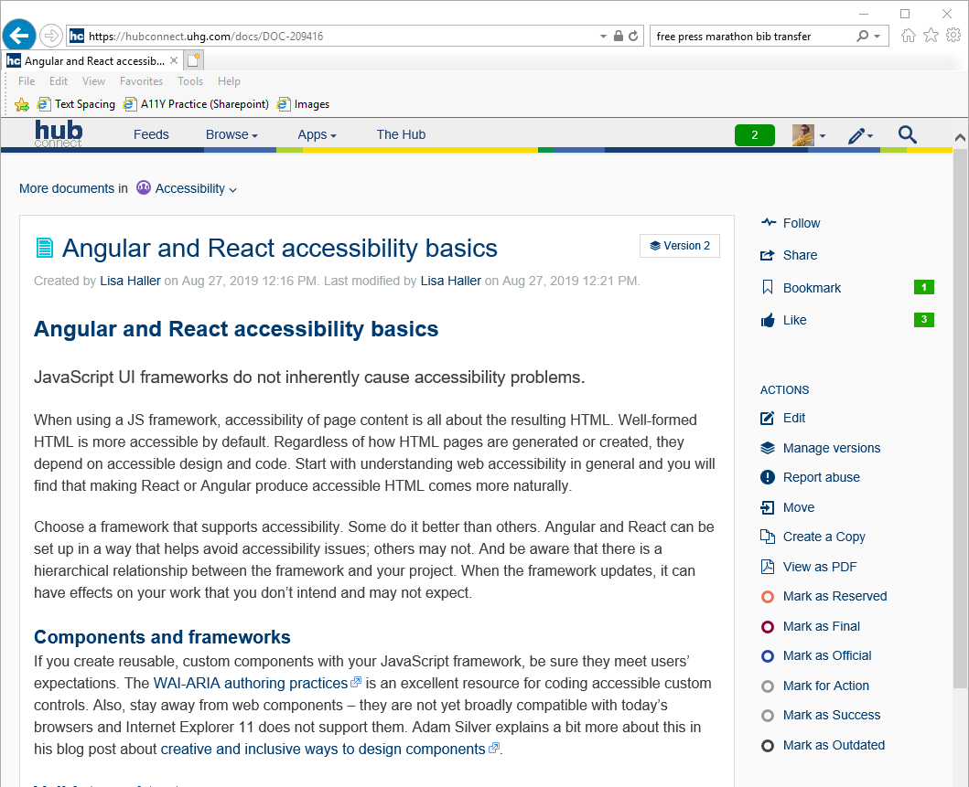

## Additional topics